MULTI AGENT AUTOMOTIVE SYSTEM

  - Course Name: Datagami

Institution Name: Medicaps University – Datagami Skill Based Course

Student Name(s) & Enrolment Number(s):
Sr no | Student Name | Enrolment Number
1 | Sarthak Chaturvedi | EN22CS301873
2 | Samar Gurjar | EN22CS301850
3 | Sarthak Chouhan | EN22CS301875
4 | Sarthak Shukla | EN22CS301878
5 | Anurag Agrawal | EN22CS301168

Group Name: D8 01
Project Number:
Industry Mentor Name:
University Mentor Name:
Academic Year:

Problem Statement & Objectives

Problem Statement : The automotive industry produces extensive data related to vehicle specifications, performance metrics, pricing, fuel efficiency, safety features, and market positioning. However, accessing structured, well-organized, and AI-generated automotive insights for a specific vehicle remains challenging for users.

There is a growing need for an intelligent system that can automatically generate comprehensive automotive reports using artificial intelligence. The system should be capable of researching vehicle information, structuring it properly, and presenting it in a professional report format through a collaborative multi-agent architecture.

Project Objectives : To design and implement a Multi-Agent Automotive Intelligence System.

To develop specialized AI agents for research and report generation.

To demonstrate inter-agent communication and orchestration.

To deploy a full-stack AI application using cloud services.

To generate structured automotive analysis reports dynamically based on user input.

Scope of the Project : The project focuses on generating AI-based automotive reports for user-specified car models. It uses a multi-agent architecture consisting of a Research Agent and a Writer Agent coordinated through an orchestrator.

The system includes:

A web interface for user interaction

A backend API for processing requests

Cloud deployment for public accessibility

The current scope is limited to AI-generated textual automotive reports and does not include real-time dealership integration, live scraping, or predictive analytics models.

Proposed Solution
- Key features: The system is built on a multi-agent architecture that enables specialization and task delegation between agents. It provides AI-powered automotive report generation and supports cloud-based deployment for public accessibility. The project includes REST API integration for communication between frontend and backend components. It offers an interactive web interface that allows users to easily request automotive reports. The modular design ensures scalability and maintainability of the system (Just mention key features here no need to go into details)

- Overall Architecture / Workflow : The system follows a client-server architecture where the frontend communicates with the backend via HTTP requests. The user enters a car name into the Streamlit interface, which sends a POST request to the FastAPI backend. The backend validates the request using a structured data model and triggers the orchestrator. The orchestrator sequentially activates the Research Agent and the Writer Agent. The Research Agent generates structured automotive insights using a large language model, and the Writer Agent converts those insights into a formatted analytical report. The backend then sends the final response back to the frontend, where it is displayed to the user. This workflow demonstrates clear separation of responsibilities and efficient coordination among system components.

- Tools & Technologies Used : The project is developed using Python as the primary programming language. FastAPI is used to build the backend API, while Streamlit is used to create the frontend interface. LangChain is implemented for agent orchestration and prompt management, and the Groq LLM API is used for language model integration. Git and GitHub are used for version control, and cloud deployment is achieved using Render for the backend and Streamlit Cloud for the frontend. REST APIs are utilized for communication between system components (If applicable)

Results & Output

- Screenshots / outputs 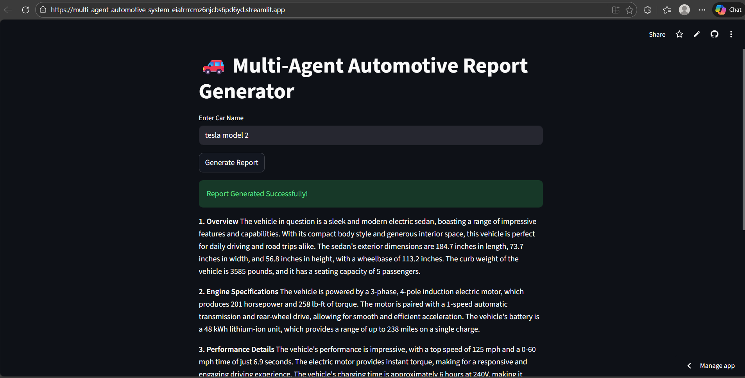
- Reports/Models : The primary output of this project is an AI-generated structured automotive report produced dynamically based on user input. The system does not use traditional machine learning prediction models or data visualization dashboards; instead, it leverages a large language model through a multi-agent architecture to generate analytical automotive intelligence reports. The generated report acts as the core analytical output of the system. While the current implementation focuses on textual report generation, the architecture supports future expansion into dashboard visualization and predictive modeling modules. The system demonstrates how large language models can function as intelligent analytical engines in place of conventional static dashboards or pre-trained ML modelsKey outcomes

Conclusion :

The Multi-Agent Automotive Intelligence System demonstrates the successful implementation of a collaborative AI architecture that integrates frontend, backend, and cloud deployment technologies. The project showcases how specialized agents can work together to automate complex analytical tasks such as automotive report generation. Through this project, we gained practical knowledge in AI orchestration, API integration, deployment strategies, and full-stack development. The system highlights the potential of multi-agent systems in building intelligent and scalable applications.

Future Scope & Enhancements
The system can be further enhanced by integrating real-time automotive data sources to provide more accurate and updated information. Future improvements may include adding a vehicle comparison feature, implementing downloadable PDF report generation, incorporating data visualizations and dashboards, and introducing user authentication with database storage. The project can also be expanded to include predictive analytics and market trend analysis. Additionally, adopting advanced agent frameworks such as CrewAI could enable autonomous task delegation and more complex multi-agent interactions.

